NXTDataLogger/NXJChartingLogger Passthrough Protocol Definitions
Kirk P. Thompson
lejos@mosen.net
4/16/2012

Defines message structure for passthrough messages COMMAND_PASSTHROUGH in (NXT-side) lejos.util.NXTDataLogger and (PC-side) lejos.pc.charting.LoggerProtocolManager.

Common Headers
  - Common/Shared Header. lejos.util.LogMessageManager.tunnelTheMessage(int, int, byte[])
Byte | ID | datatype | desc
0 | Command | ubyte | See 1.1.1. Header commands
1 | Target Handler TYPE | ubyte | The handler TYPE ID
2-3 | Packet size | ushort | The data package size in bytes. Pulls the data from DIS and passes entire “packet” to target handler.
4-n | Packet | byte array | The payload (commands, data)
    - Header commands
Command | function | note
0 | INIT and load Target Handler TYPE panel/tab. See 2. INIT Target handler on NXT Charting Logger | used by TunneledMessageManager. Set packet size=1 and packet value[0]=Handler ID
1 | Close Target Handler TYPE panel/tab | Set packet size=0. NOT IMPLEMENTED as of 4/30/12
2 | Set panel “Name” field. See 3. Set Panel Name. | Set packet size=1+n(where n=string len) and packet value[0]=Handler ID, value[1-n] to contain string
3 | Deliver data packet to handler. See 4. Target Handlers | Define packet data (and thus size)

INIT Target handler on NXT Charting Logger
packet consists of
Byte | ID | datatype | desc
0 | Handler ID | byte | Handler unique ID per handler type. Always byte 0
1 | String size | byte | The message. 255 max length.
2-n | String value | byte[] | String value encoded as US-ASCII

Set Panel Name
Byte | ID | datatype | desc
0 | Handler ID | byte | Handler unique ID per handler type. Always byte 0
1 | String size | byte | The message. 255 max length.
2-n | String value | byte[] | String value encoded as US-ASCII

Target Handlers
Parsed from data packet (1.1, bytes 4-n) parsed from Common Header and passed via the processMessage() method.

NXT-side: TYPE_ID is passed from Common Header via lejos.util.LogMessageTypeHandler.processMessage(byte[], int).

Handlers must always implement Byte[0] as the handlerID and decide if it wants to handle the message as it is received: i.e. if the handler ID matched.

Handlers must have Getters and Setters for any values required from NXT on poll since a poll (from PC) GET triggers a NXT SET which travels back to PC as a SET with the requested value. Getters are not required for NXT write only (i.e. button actions).

Handlers are responsible for packing their own handler-specific protocol values into an array that will be sent as passthrough data packet specified in 1.1, bytes 4-n.
- NXT implementation: lejos.util.LogMessageTypeHandler.sendMessage(int, byte[], int, int)
- PC implementation: lejos.pc.charting.AbstractTunneledMessagePanel.sendMessage(int, byte[], int, int)

  - NOT IMPLEMENTED as of 5/22/12. Target Handler 0: Broadcast Message handler (all handlers)
Byte | ID | datatype | desc
0 | Handler ID |  | Handler unique ID per handler type. Always byte 0
1-n | Data package | byte[] | The message??? TODO

  - Target Handler 1: PID tuning handler
Byte | ID | datatype | desc
0 | Handler ID | ubyte | Handler unique ID per handler type. Always byte 0
1 | Command. See . | ubyte | Handler command
2-5 | Command DataValue. See . | [varies] | See PID tuning Commands below. GETs use no value but sends a return SET message with the current value.

    - PID tuning Commands
Command | function | datatype | note
0 | Set Kp | float
1 | Get Kp |  | Responds with SET msg with value (typ)
2 | Set Ki | float
3 | Get Ki
4 | Set Kd | float
5 | Get Kd
6 | Set rampExponent | float
7 | Get rampExponent
8 | Set rampTriggerThreshold | float
9 | Get rampTriggerThreshold
10 | Set MVDeadband | float
11 | Get MVDeadband
12 | Set MVHighLimit | float
13 | Get MVHighLimit
14 | Set MVLowLimit | float
15 | Get MVLowLimit
16 | Set integralWindupLowLimit | float
17 | Get integralWindupLowLimit
18 | Set integralWindupHighLimit | float
19 | Get integralWindupHighLimit
20 | Set SP | float
21 | Get SP
22 | Set delay | int
23 | Get delay
24 | Set integralFrozen | byte | !=0 => true
25 | Get integralFrozen |  | !=0 => true

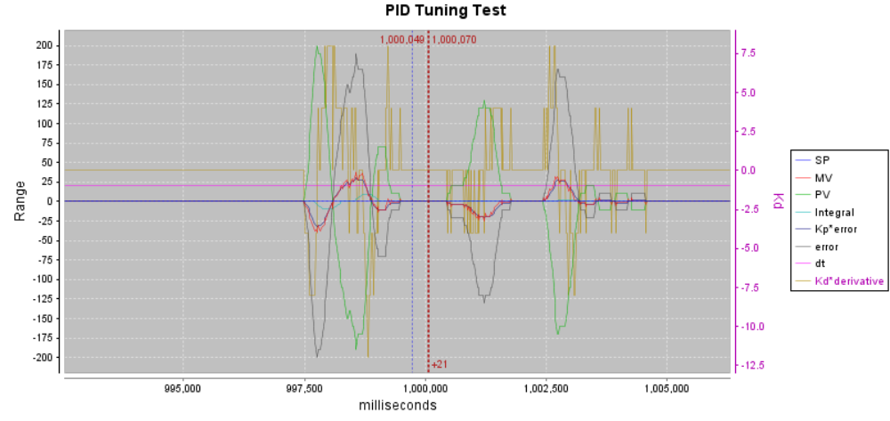

  - Target Handler 2: Simple Driver handler
Byte | ID | datatype | desc
0 | Handler ID | ubyte | Handler unique ID per handler type. Always byte 0
1 | Command. See . | ubyte | Handler command
2-n | Command DataValue. See 4.3.1 | [varies] | See Simple driver Commands below. GETs use no value but sends a return SET message with the current value.
    - Simple Driver Commands
Command | function | Target | data  type | note
0 | Set driveForward | NXT | byte | 1=button pressed, 0=released
1 | Set driveBackward | NXT | byte | 1=button pressed, 0=released
2 | Set driveTurnLeft | NXT | byte | 1=button pressed, 0=released
3 | Set driveTurnRight | NXT | byte | 1=button pressed, 0=released
4 | Set power | both | int | 0-100 (%)
5 | Get power | both
6 | Set Command 1 | NXT | byte | 1=button pressed, 0=released
7 | Set Command 2 | NXT | byte | 1=button pressed, 0=released
8 | Set Command 3 | NXT | byte | 1=button pressed, 0=released
9 | Set Command 4 | NXT | byte | 1=button pressed, 0=released
10 | Set Command 1 1abel | PC | byte[] | US-ASCII character string
11 | Get Command 1 1abel | PC
12 | Set Command 2 1abel | PC | byte[] | US-ASCII character string
13 | Get Command 2 1abel | PC
14 | Set Command 3 1abel | PC | byte[] | US-ASCII character string
15 | Get Command 3 1abel | PC
16 | Set Command 4 1abel | PC | byte[] | US-ASCII character string
17 | Get Command 4 1abel | PC
18 | Set Value Field 1 | both | float
19 | Get Value Field 1 | both
20 | Set Value Field 2 | both | float
21 | Get Value Field 2 | both
22 | Set Value Field 3 | both | float
23 | Get Value Field 3 | both
24 | Set Value Field 4 | both | float
25 | Get Value Field 4 | both
26 | Set Value 1 1abel | PC | byte[] | US-ASCII character string
27 | Get Value 1 1abel | PC
28 | Set Value 2 1abel | PC | byte[] | US-ASCII character string
29 | Get Value 2 1abel | PC
30 | Set Value 3 1abel | PC | byte[] | US-ASCII character string
31 | Get Value 3 1abel | PC
32 | Set Value 4 1abel | PC | byte[] | US-ASCII character string
33 | Get Value 4 1abel | PC

  - Target Handler 3: Debug console
Byte | ID | datatype | desc
0 | Handler ID | ubyte | Handler unique ID per handler type. Always byte 0
1 | Command. See . | ubyte | Handler command
2-n | Command DataValue. See 4.3.1 | [varies] | See Debug Console Commands below. GETs use no value but sends a return SET message with the current value.
    - Debug Console Commands
Command | function | Target | data  type | note
0 | Set Message | PC | byte[] | US-ASCII character string

